**Exercise 1: Control Structures**

**Scenario 1:** The bank wants to apply a discount to loan interest rates for customers above 60 years old.

**Question:** Write a PL/SQL block that loops through all customers, checks their age, and if they are above 60, apply a 1% discount to their current loan interest rates.

**PL/SQL Block :-**

DECLARE

CURSOR cur_senior_customers IS

SELECT CustomerID, DOB

FROM Customers;

v_customer_id Customers.CustomerID%TYPE;

v_dob Customers.DOB%TYPE;

v_age NUMBER;

BEGIN

FOR rec IN cur_senior_customers LOOP

v_customer_id := rec.CustomerID;

v_dob := rec.DOB;

-- Calculate age

v_age := FLOOR(MONTHS_BETWEEN(SYSDATE, v_dob) / 12);

-- If age > 60, apply 1% discount to loan interest

IF v_age > 60 THEN

UPDATE Loans

SET InterestRate = InterestRate * 0.99

WHERE CustomerID = v_customer_id;

DBMS_OUTPUT.PUT_LINE('Updated InterestRate for Customer ID: ' || v_customer_id || ', Age: ' || v_age);

END IF;

END LOOP;

END;

/

**Table :-**

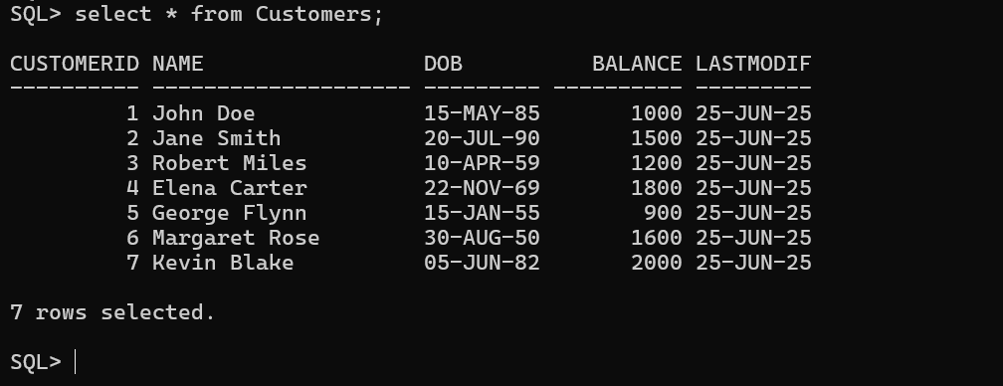

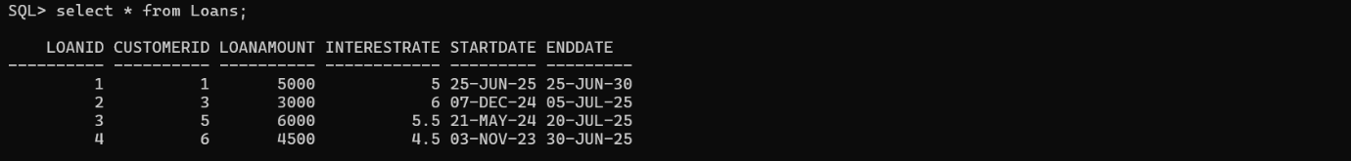

**Output :-**

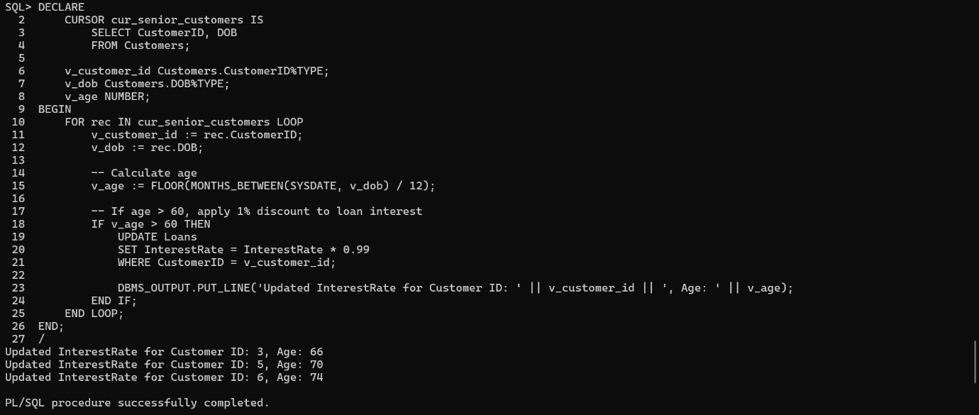

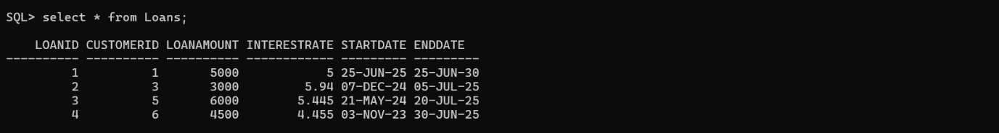

**Scenario 2:** A customer can be promoted to VIP status based on their balance.

**Question:** Write a PL/SQL block that iterates through all customers and sets a flag IsVIP to TRUE for those with a balance over $10,000.

**PL/SQL Block :-**

BEGIN

FOR rec IN (SELECT CustomerID, Balance FROM Customers) LOOP

IF rec.Balance > 10000 THEN

UPDATE Customers

SET IsVIP = 'TRUE'

WHERE CustomerID = rec.CustomerID;

DBMS_OUTPUT.PUT_LINE('Customer ' || rec.CustomerID || ' promoted to VIP.');

END IF;

END LOOP;

END;

/

**Table :-**

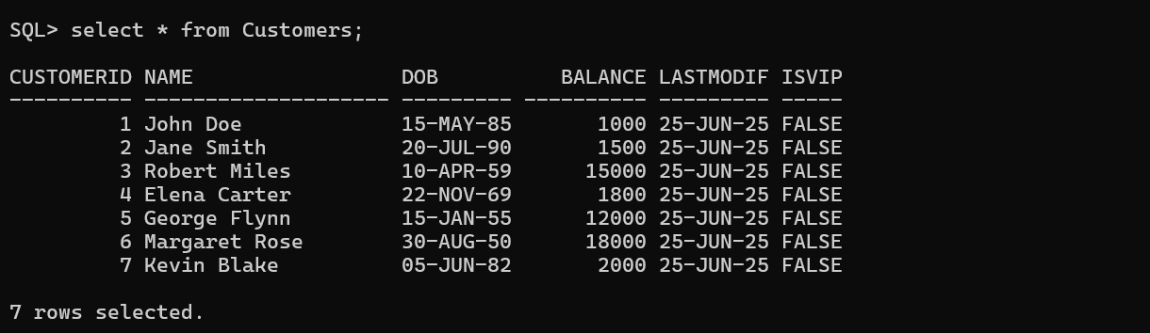

**Output :-**

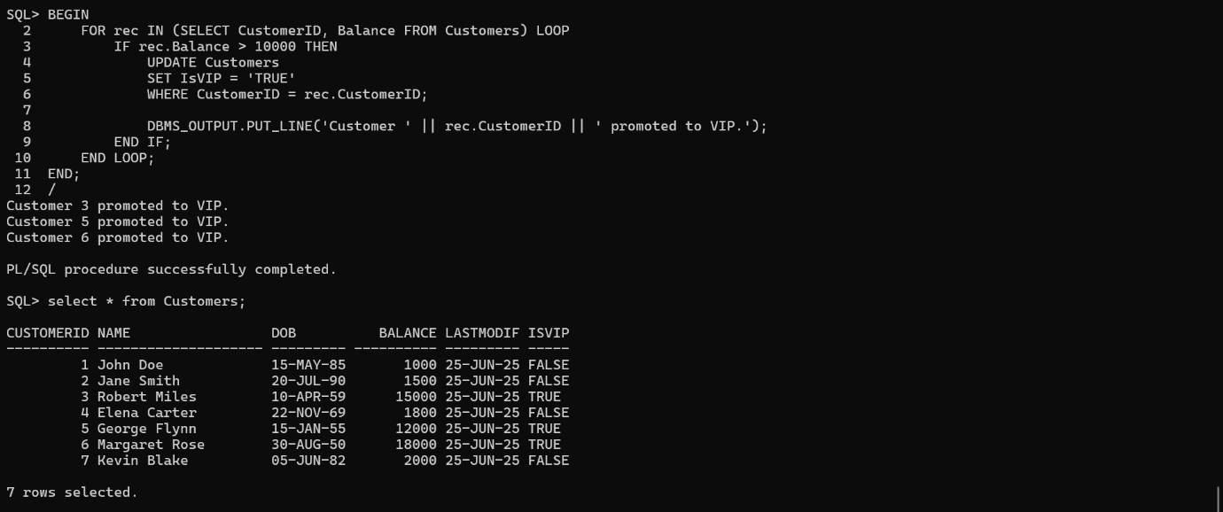

**Scenario 3:** The bank wants to send reminders to customers whose loans are due within the next 30 days.

**Question:** Write a PL/SQL block that fetches all loans due in the next 30 days and prints a reminder message for each customer.

**PL/SQL Block :-**

BEGIN

FOR loan_rec IN (

SELECT l.LoanID, l.CustomerID, l.EndDate, c.Name

FROM Loans l

JOIN Customers c ON l.CustomerID = c.CustomerID

WHERE l.EndDate BETWEEN SYSDATE AND SYSDATE + 30

) LOOP

DBMS_OUTPUT.PUT_LINE(

' Reminder: Customer "' || loan_rec.Name ||

'" (Customer ID: ' || loan_rec.CustomerID ||

') has Loan ID ' || loan_rec.LoanID ||

' due on ' || TO_CHAR(loan_rec.EndDate, 'DD-MON-YYYY')

);

END LOOP;

END;

/

**Tables :-**

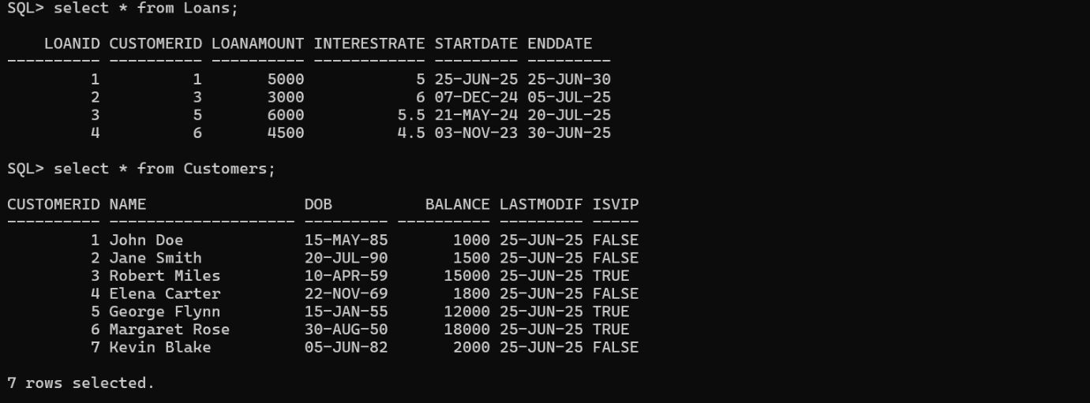

**Output :-**

